Bees and Beekeeping
Denbigh and District Probus Group

Members of the Denbigh and District Probus Club enjoyed their July
meeting with a wonderful meal at Tweedmill, St Asaph, followed by a talk titled Bees and Biodiversity from speaker Barry Griffiths (also known in some areas as Barry Bees!!)

Barry has been a beekeeper for many years and is the ex-chair of Conwy beekeepers. His role as a Town Councillor has added to his interest in and concern for our nature in terms of biodiversity. He is a keen photographer and continually adds to his library of photos. He worked at Pilkington Optronics for many years, started his own digital business and now volunteers in the community.

He explained how the UK is supposedly the most nature depleted country on Earth and reminded members of when they used to scrape insects off the windscreen and how there are far less today. Most species are not extinct but have depleted and many can be seen if we look and create areas for forage and habitat.

All bees go through four distinct developmental stages which are egg, larva, pupa, and adult. The queen lays a single egg in a honeycomb cell, which hatches into a worm-like larva in three to four days. It is then sealed with wax to become a pupa, before finally chewing out as an adult. A colony of bees may typically consist of tens of thousands of individuals. A female honeybee lives for about six weeks.

Bees pollinate flowers whilst gathering food - a mutually beneficial partnership between bees and flowering plants. Bees are attracted to flowers because of their bright colours and sweet scents. Plants provide nectar (a sugary, high-energy liquid) and pollen (a protein-rich food source).

The main species of bees are bumble, honey, mason and Hylaeus with many sub species – 20,000 at least. There are solitary species e.g. minor bee which live in a hole in the ground, making tunnels for a small amount of brood.

Barry also touched on diseases and conditions that affect bees including Varroa destructor mite, which transmits lethal viruses like Deformed Wing Virus.

Bees are not the only pollinating insect by far with plant and wildlife biological diversity improvement being a vital factor in our nature recovery. We are encouraged to observe our local environment (garden, window box) and manage local plant species that attract wildlife like pollinating insects in a continuous process.
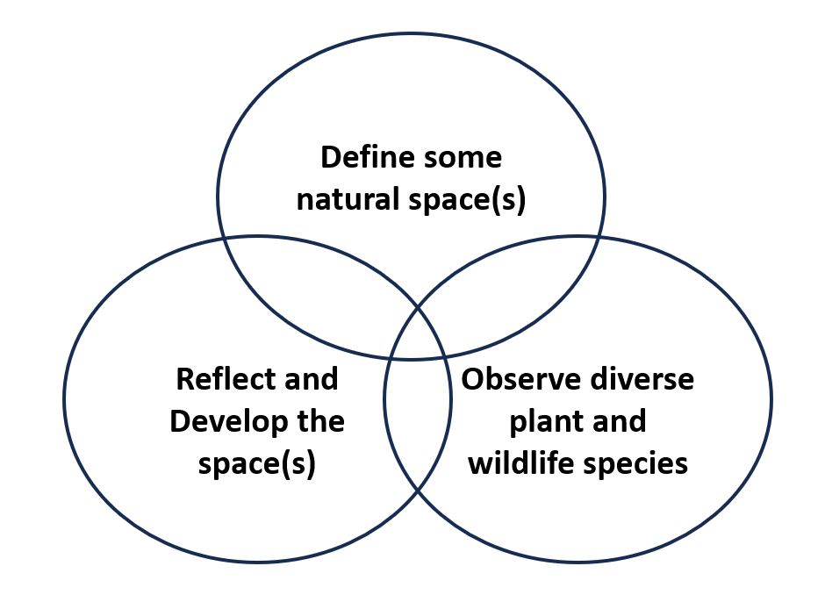
A wide range of pollinating insects were presented from hover flies to butterflies, bumble bees to the Yellow Legged Hornet which is an imminent threat to UK pollinators.

Barry and colleagues have put much effort into working closely with a local solar park run by Schoders Greencoat and the mutual agreement has meant a genuine improvement in biodiversity and renewables in the area. The joint work has also enabled numerous outreach projects.

Denbigh and District Probus Club is a group of business or professional women and men either approaching or enjoying retirement or semi-retirement.

New members are always warmly welcomed to the Denbigh and District Probus Club meetings.

The next club meeting will be an invitation lunch on Monday 3rd August when Clwyd Wynne will talk about The Denbigh Mental Hospital.

For further information, have a look at the club website
denbighprobus.com or contact stevetootell@gmail.com

